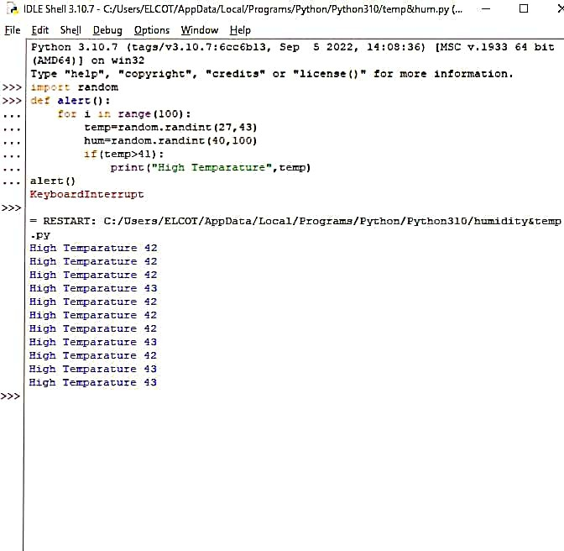 **ASSIGNMENT-2**

**TEAM ID:PNT2022TMID50270**